OCI DSP - Data Science Introduction

This is module 1, covering introduction and configuration. This first lesson is the introduction to the Oracle Cloud Infrastructure Data Science Cloud Service. I'm Wes Pritchard, senior principal product manager for Data Science and AI Services.
Before we get into data science and Oracle, let's take a fun look back at history and how we got here. In the 1300s, William Ockham, a philosopher and friar, believed that scientists should prefer simpler theories over more complex ones. The principle that bears his name, known as Ockham's razor, can be applied to machine learning by looking for the simplest solution.
In the mid 1700s, astronomer Tobias Mayer made a quantitative argument that more data is better. He was studying the motions of the moon and collected 9 times as many data points as necessary, claiming that this made his observations more accurate. Because of this, he's often considered the first true data scientist.
In 1952, Arthur Samuel, an IBM pioneer in computing, gaming, and AI coined the term machine learning. He designed a game for playing checkers and discovered that the more the computer played the game, the more it learned winning strategies from experience.
In 1962, mathematician John W Tukey predicted the effect of modern day electronic computing on data analysis as an empirical science. However, Tukey's predictions occurred decades before the explosion of big data and the ability to perform complex and large scale analysis.
1997, an IBM supercomputer called Deep Blue defeated chess grandmaster Garry Kasparov in only 19 moves. Kasparov resigned after this match. The highly advanced supercomputer could calculate as many as 100 billion to 200 billion positions in the three minutes traditionally allotted to a player per move in standard chess.
In 2008, Dr. DJ Patil of LinkedIn and Jeff Hammerbacher of Facebook coined the term data science to describe an emerging field of study that focused on teasing out the hidden value and collected data from retail and business sectors.
Given that historical background, let's take a look at how data science is being applied today. 2021, in the midst of a global COVID-19 pandemic, professor and psychologist Anthony Klotz coined the term the Great Resignation to describe a new trend of employment, dissatisfaction, and turnover. Many businesses want to track, analyze, and predict the patterns in their employee retention.
In this course, we will use employee attrition as a use case to connect our machine learning activities to a real world business problem. Better yet, we will help you build a predictive ML model yourself in the independent student lab that accompanies this course.
Now it's time to dive in and discuss Oracle's approach to data science and AI. It's really all about data.
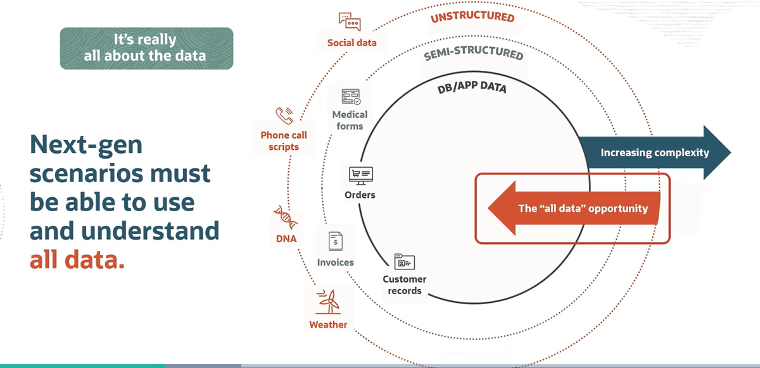
For many years, the data available to organizations was the structured data in their business applications. And this is still very important business data, but it's certainly not the only data. Organizations have many types of unique and often unstructured data from many different sources, things like equipment sensors, mobile apps, social media, customer interactions via voice and text, videos, images, documents, and many more.
Organizations want to use all data to produce new insights and new data products. They want to improve their business operations by creating better customer experiences and anticipating service demand and preventing avoidable equipment outages. The next generation of business problems or scenarios, if you will, means being able to use all data. And we need the capabilities provided by data science, machine learning, and AI understand and use that data.
Oracle AI is this portfolio of cloud services for helping organizations take advantage of all data for the next generation of scenarios.
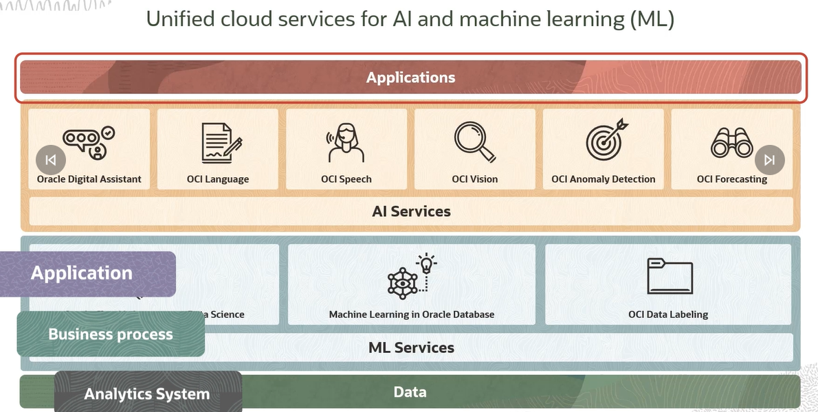
Thus the foundation of all of this is data. It's a bar at the bottom. Obviously, AI and machine learning work on data and require data. Now, the top layer of this diagram is applications, and this loosely refers to all the way AI's consumed. That could be an application, business process, or an analytic system.
Between the application and data layers, you see two groups here, the AI services on top and the machine learning services on the bottom. The difference between the two groups is that machine learning services are used primarily by data scientists to build, train, deploy, and manage machine learning models. Data scientists can work with familiar open-source frameworks and OCI Data Science. And by the way, that's the cloud service, that's the focus of this course.
Data scientists and database specialists can take advantage of machine learning algorithms built into Oracle database. And an important service that supports both machine learning and AI services is OCI data labeling. Because when you're building machine learning models that work on images, text or speech, you need labeled data that can be used to train the models.
AI services contain pre-built machine learning models for specific uses. Some of the AI services are pre trained and some are trained by the customer with their own data. All are used by simply calling the API for the service, passing in data to be processed, and the service returns a result. There's no infrastructure to manage. And even though we will be focusing primarily on OCI Data Science in this course, we also have some lessons on the AI services and on data labeling. There's already a separate course that covers machine learning and Oracle database.

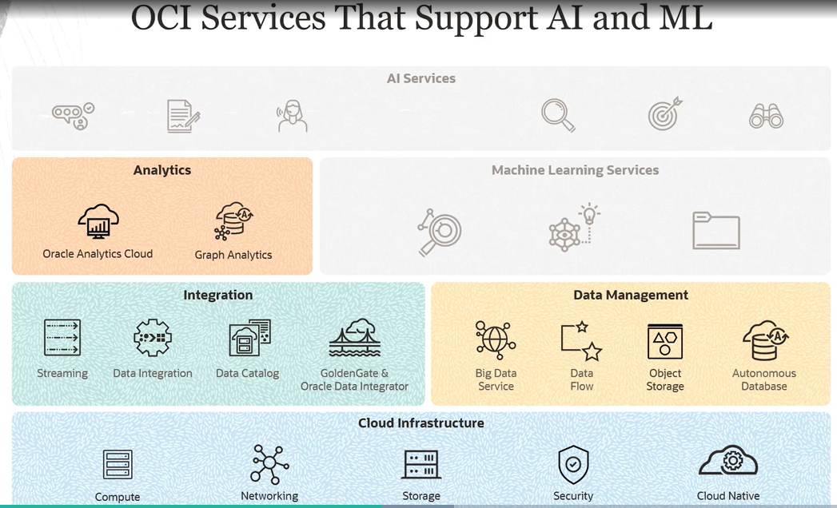

Now, those AI and ML services I just showed you don't standalone. They're supported by many other services available in our cloud infrastructure including business analytics and graph analytics and many forms of data integration and data management, all running on the basic cloud infrastructure. These services can be combined in various architectures to support many different scenarios.
We've defined Oracle AI and the services it comprises. Now, let's take a closer look at Oracle Cloud Infrastructure Data Science. I'm just going to abbreviate it as OCI Data Science. OCI Data Science is the cloud service focused on serving the data scientists throughout the full machine learning lifecycle, with support for Python and open-source. As you can see by the icons in this graphic, the service has many features that we will cover throughout this course.
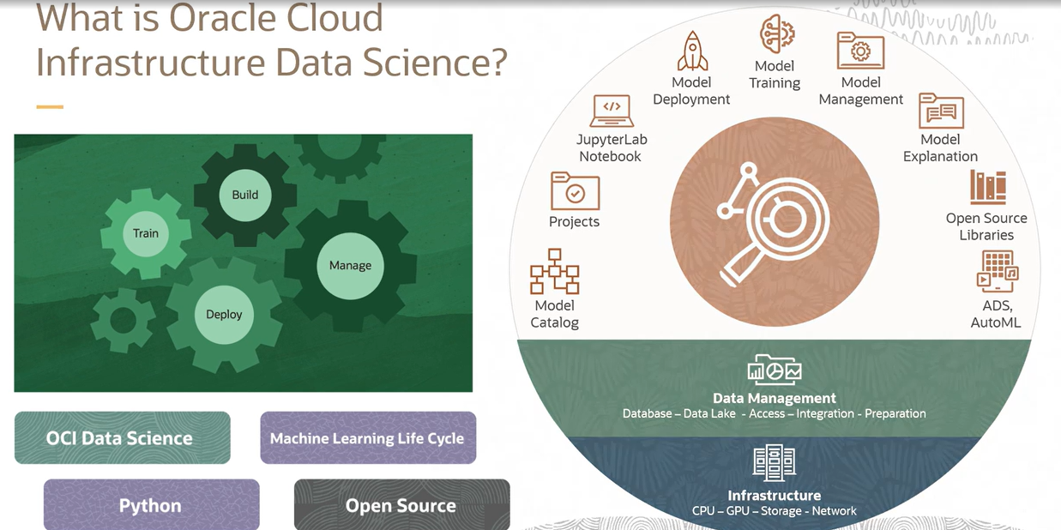

Now, let's look at the three core principles that guide the product.
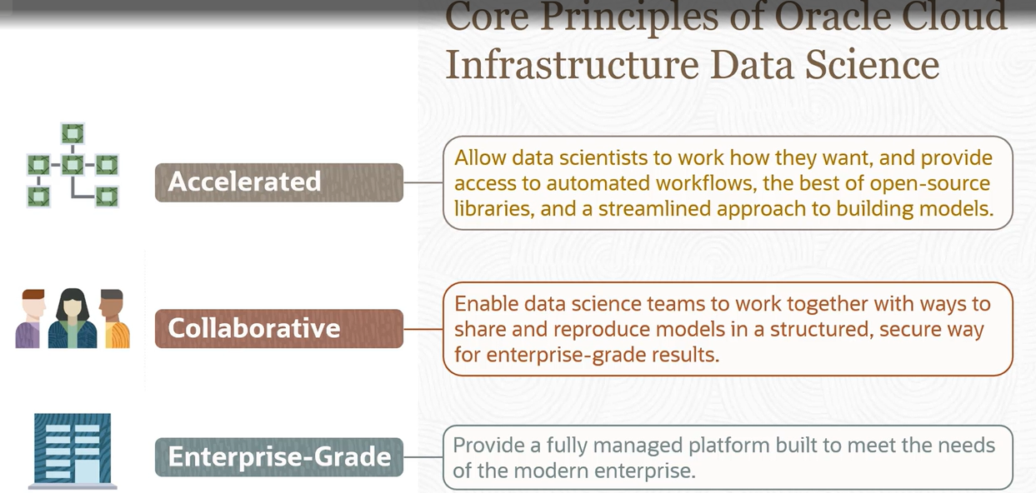
The first principle is about accelerating the work of the individual data scientists. Data scientists coming out of universities today have been trained using open-source, and that's what they're most comfortable with. But using open-source tools on a laptop means managing lots of libraries from different sources, and being limited to the compute power on the laptop.
OCI Data Science provides data scientists with open source libraries along with easy access to a range of compute power without having to manage any infrastructure. It also includes Oracle's own library to help streamline many aspects of the data scientists work.
Our second principle is collaboration. It goes beyond individual data scientist productivity to enable data science teams to work together. This is done through the sharing of assets reducing duplicative work and supporting reproducibility and auditability of models for collaboration and risk management.
And the third principle is about being enterprise grade. That means it's integrated with all the OCI security and access protocols. Underlying infrastructure is fully managed. Customer doesn't have to think about provisioning compute and storage and the service handles all the maintenance, patching, and upgrades so users can focus on solving business problems with data science.
Let's drill down a bit more into the specifics of OCI Data Science.
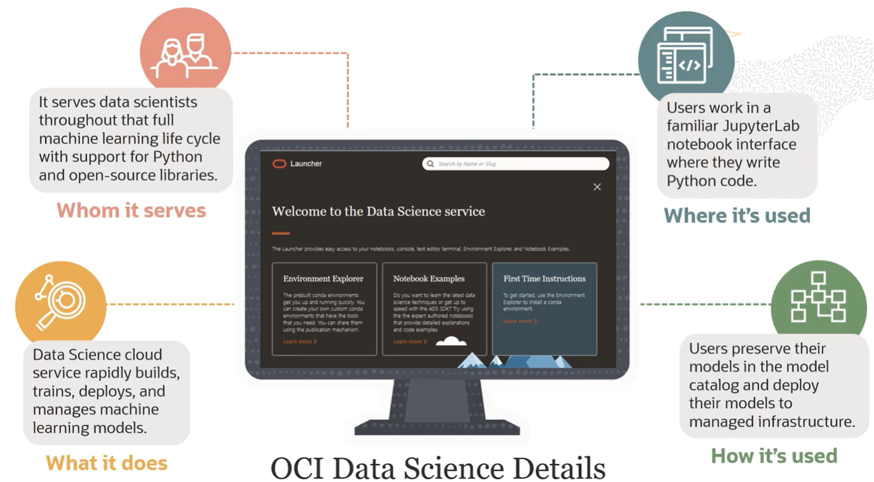

First of all, it's a cloud service to rapidly build, train, deploy, and manage machine learning models. It serves data scientists and data science teams throughout the full machine learning lifecycle with support for Python and open-source. Users work in a familiar JupyterLab notebook interface where they write Python code. And users preserve their models in the model catalog and deploy their models to manage the infrastructure.
Let's cover some important product terminology that we'll use throughout the course. Take some time to digest these terms and concepts.
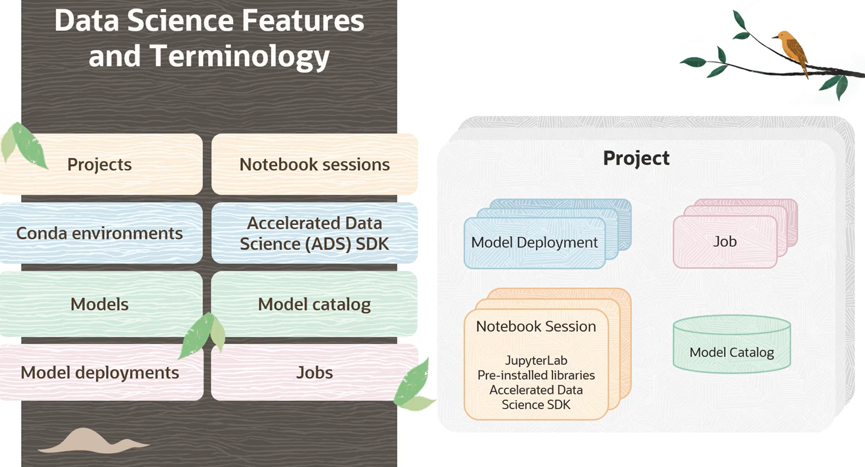

Projects are containers that enable data science teams to organize their work. They represent collaborative workspaces for organizing and documenting data science assets such as notebook sessions, models. Note that a tenancy can have as many projects as needed without limits.
Notebook sessions are where data scientists work. Notebook sessions provide a JupyterLab environment with pre-installed open-source libraries and the ability to add others. Notebook sessions are interactive coding environments for building and training models. Notebook sessions run in managed infrastructure, and the user can select CPUs or GPUs and the compute shape and the amount of storage without having to do any manual provisioning of environments.
Conda is an open-source environment and package management system that was created for Python programs. It's used in the data science service to quickly install, run, and update packages in their dependencies. Conda easily creates, saves, loads, and switches between environments on or in the notebook environment.
Oracle's Accelerated Data Science, SDK, and we're going to call that ADS throughout this course, but the ADS SDK is a Python library that is included as part of OCI Data Science. ADS has many functions and objects that automate or simplify the steps in the data science workflow, including connecting to data, exploring and visualizing data, training a model with AutoML, evaluating models, and explaining models. In addition, ADS provides a simple interface, access the data side service model catalog and other OCI services, including object storage.
Now, you already know what a model is. Models define a mathematical representation of your data and business. You create models in notebook sessions inside projects. The model catalog is the place to store tracks, share, and manage those models. Model catalog is a centralized and managed repository of model artifacts. A stored model includes metadata about the provenance of the model including get related information and the script or notebook used to push the model to the catalog. Models stored in the model catalog can be shared across members of a team, and they can be loaded back into a notebook session.
Model deployments allow you to deploy models stored in the model catalog as HTTP endpoint on managed infrastructure. Deploying machine learning models as web applications serving predictions in real time is the most common way to operationalize models. HTTP endpoints are flexible and can serve requests for model predictions.
Data science jobs enable you to define and run repeatable machine learning tasks on fully managed infrastructure. We'll see how data science provides multiple methods for access. OCI Console is the most common method. The OCI Console provides an easy to use browser based interface that enables access to notebook sessions and all the features of the service. This will be the interface used throughout the course.
The Rest API provides access to service functionality that requires programming. An API reference is provided in the product documentation. OCI also provides programming language SDKs for Java, Python, TypeScript, JavaScript, .NET, Go, and Ruby. These SDKs enable a user to write code and manage data science resources. We'll provide some examples of how the Python SDK can be used to deploy models and create jobs. The command line interface provides both quick access and full functionality without the need for scripting.

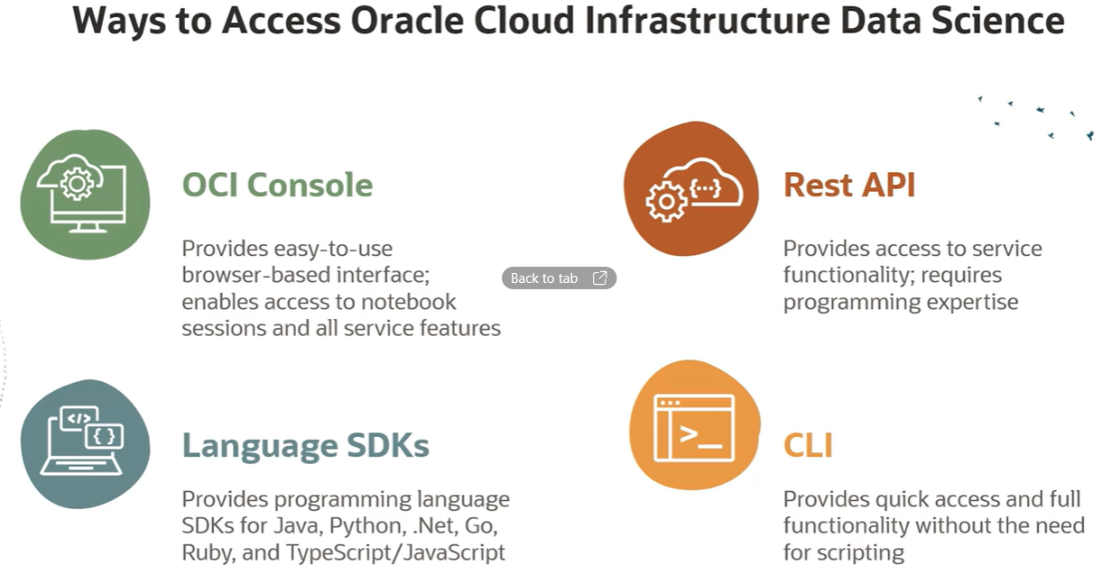

As a Cloud Service on OCI, OCI Data Science is available through regions. Regions are globally distributed data centers that provide secure high performance local environments. That makes OCI Data Science available around the globe in commercial, government, and dedicated regions. Oracle is frequently adding new regions, so visit oracle.com/cloud to get the latest information on Cloud regions.
In this lesson, we introduce OCI Data Science and some of its key features and terminology. The next lesson will cover provisioning and configuring the cloud environment to use OCI Data Science throughout the machine learning lifecycle.

